|  |  |
| --- | --- |
| https://2016.hackerspace.govhack.org/sites/default/files/field/image/Snap%20Ranger%20Logo.png  **SNAP RANGER** | **GOV HACK 2016** |

**SNAP RANGER**

**Descriptive Project Page**

|  |  |
| --- | --- |
| **Team:** | **EmpowerRangers** |
| **Project:** | **SNAP RANGER** |
| **Team Members:** | Luke Thorpe  Sebastian Schimdt  Steffi Tan  Jack Chiang  Jonathan Romero  Rubiana Cury  Alan Monardes |
| **Team Captain:** | Luke Thorpe |
| **Nomination Prizes:** | **MAJOR CATEGORY PRIZES**   * Innovative Ideas Hack (AFSA & Queensland Government) * Inspired by Research Hack (DATA61 & AIHW)   **QUEENSLAND**   * Create a Cutting Edge Concept – The Science Sandpit! (The Queensland Government on behalf of Science Division, Department of Science, Information Technology and Innovation) * Advance Queensland! (Queensland Government on behalf of Strategic Policy and Innovation, Department of Science, Information Technology and Innovation) * Educate us! (Queensland Government on behalf of the Department of Education and Training)   **GOLD COAST**   * Best of Gold Coast (City of Gold Coast) * Best Use of Gold Coast Data (City of Gold Coast) * Entrepreneurs Award (City of Gold Coast) |

**Description of the Project**

Why not provide extra help to our rangers?

The **SNAP RANGER** app aims to engage the local community with the Gold Coast wildlife.

Australia is filled with unique animals which many of them can be found on the Gold Coast. Because Gold Coast is one of the most biodiverse cities in Australia and, at the same time, with the highest rates of city growing, the Council has set a Nature Conservation Strategy (2009-2019) focus on preserve the biodiversity. As part of the Strategy outcomes expected, the Snap Ranger is able to approach the *(2) The Gold Coast community has an appreciation, awareness and involvement with the natural environment; (6) Nature conservation is achieved through partnerships that promote, research, invest in, and coordinate the management of the city’s biodiversity.*

Snap Ranger provides the means to identify and educate oneself about local wildlife whilst enjoying the Gold Coast's scenic nature. Also, it allows you to help our rangers to protect our fauna and flora as the conscience and enjoyment with those natural resources can bring awareness regarding the importance of preserve them.

Using a digital map on the Snap Ranger app, a user can travel to known locations in the real world to try and find animals whose locations have been recorded by previous government studies. When an animal of significance is located, he can take a photo and log the record. Upload images and complete your understanding of nature on the Coast. The user can also comment on where he discovered the animal to assist future Snap Ranger‘s as well as future government studies. Snap Ranger includes national parks location, endangered animal locations and places where studies have been recorded regarding the environment on the Gold Coast.

For those who love nature, image and the Gold Coast.

For this app, open data from National Database, Queensland Government, Gold Coast City Council have been used.

**Technology Applied**

For SNAP RANGERS app, the following languages have been used:

* HTML 5
* CSS
* Java Script
* JSON, CSV

**Benefits of the app**

Promotion of Environmental Education

Promotion of Interaction with Wildlife

Engagement of the community with the Local area and Local Wildlife

Engagement of the community with the Rangers community to preserve the environment

Facilitate tourist access to native Australian wildlife

Encouraging a healthy lifestyle

Cross database from Australia National Database, Queensland Government Database and Gold Coast Database

Promote a database regarding park visitors and animals on Gold Coast

**Functions description**

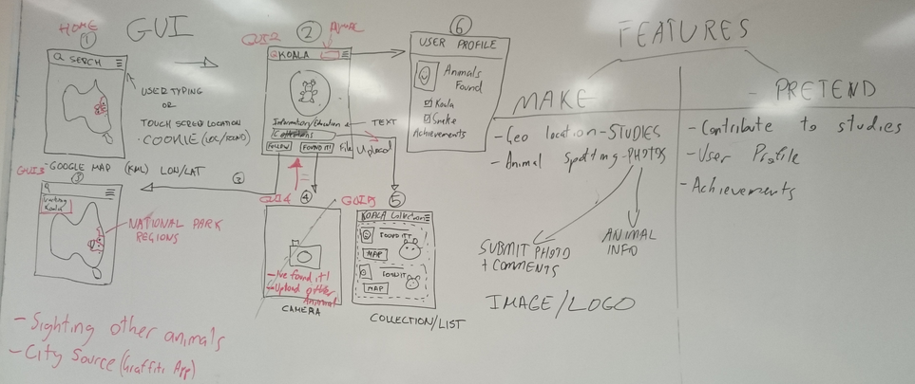

**Judging Criteria**

* **Relevance to the prize category description:**

**National:**

**(Innovative Ideas influenced by research)**

* + **Usage of species recorded by research**
  + **Alignment with the National Conservation Strategic Plan**

**State:**

**(Advance Queensland + Educate us)**

* + **Educational Environment purpose**
  + **Use of technology for education**
  + **Usage of scientific data from fauna and flora (national parks)**

**Local:**

**(Best use of Gold Coast Data + Entrepreneurs)**

* + **Usage of local data (parks and animals)**
  + **Alignment with Local Conservation Strategic Plan**
  + **Potential implementation/advertising in schools, libraries, parks and for tourists**
  + **Promotion of the Gold Coast (natural biodiversity and richness of different regions throughout the city with biodiversity potential)**
* **Specific prize eligibility criteria detailed (e.g. data use)**

**Usage of Queensland data + Gold Coast Data**

**Usage of fauna and flora data**

**Usage of research records data**

* **Originality of the concept**
* **Civic value**

**Promotion of conservation of biodiversity**

**Promotion of environmental education**

* **Visual design and usability**

**Visually appealing to engage: Maps, Dot Marks that not only can give direction but also can be recorded as ‘I’ve been here’ and pictures**

**Easy access and interaction with the data**

* **Degree to which open data has been used**
* **Technical or creative skills demonstrate**

**Interaction of people**

**Crossing data**

* **Problem Solving:** 
  + **Part of the Priorities/Goals of National and Local Conservation Strategic Plan**
  + **Smart cities concept**
  + **Engage and Inspire Community (for Conservation and awareness of richness of Queensland/Gold Coast biodiversity)**
  + **Explore research data (in deep and across institutions)**
  + **Reuses Environmental and Natural Resources Science data and improve the Government Service Delivery through information and discoverability and community engagement**
  + **Educate community and tourists regarding biodiversity and inspire conservation**
  + **Promotion of healthy lifestyle using outside activities and nature interaction**
  + **High potential for negotiation and implementation**

**Video**

Login: [empowerranger@gmail.com](mailto:empowerranger@gmail.com)

Password: snapranger

**URLs**

* **National Database**
* **Queensland Government Database**
  + *Conservation status of Queensland Wildlife – Species – Data* for Determination of which species are endangered:<https://data.qld.gov.au/dataset/conservation-status-of-queensland-wildlife/resource/1c8b4859-31a4-42e7-8e63-b7cf125d4321>
* **Gold Coast City Council Database**
  + *Nature Conservation Strategy Fauna on the Gold Coast* for Animal Location: <http://data.goldcoast.opendata.arcgis.com/datasets/cd77ebb629d0408fb27790fac5ced8a2_0?uiTab=table&geometry=152.796%2C-27.482%2C152.796%2C-27.482>

**Business and Use Potential**

Attract sponsor partners

Database from users that can be used for financial decisions and technical information

Nature explorer Touristic

**Future Improvements or Potential**

Future studies for Crowdsourcing

It can add other research database of wildlife

It can add a functionality of QR’s regarding fauna – where when a user is on a national park which has tree/plants identification, he can easily get deep information of that